# **ASSIGNMENTS**

# Name: Sneha S

# NM-ID 872D69B996AC5C1A1E741D87CB1DBA7D

# Brand Name: Floral Nova

# Assignment 1:Blog Creation

Link: <https://floralnova333.blogspot.com/2023/09/certainly-womens-footwear-includes-wide.html?m=1>

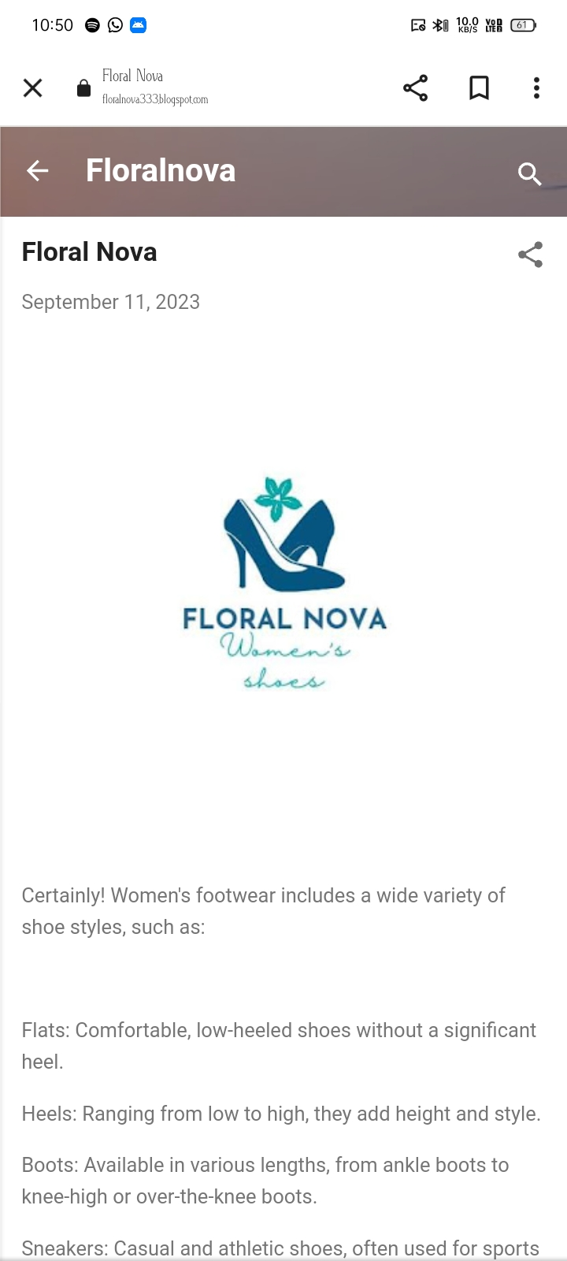

Assignment 2: Facebook Business Page Creation

Link:<https://www.facebook.com/profile.php?id=61550730475112&mibextid=ZbWKwL>

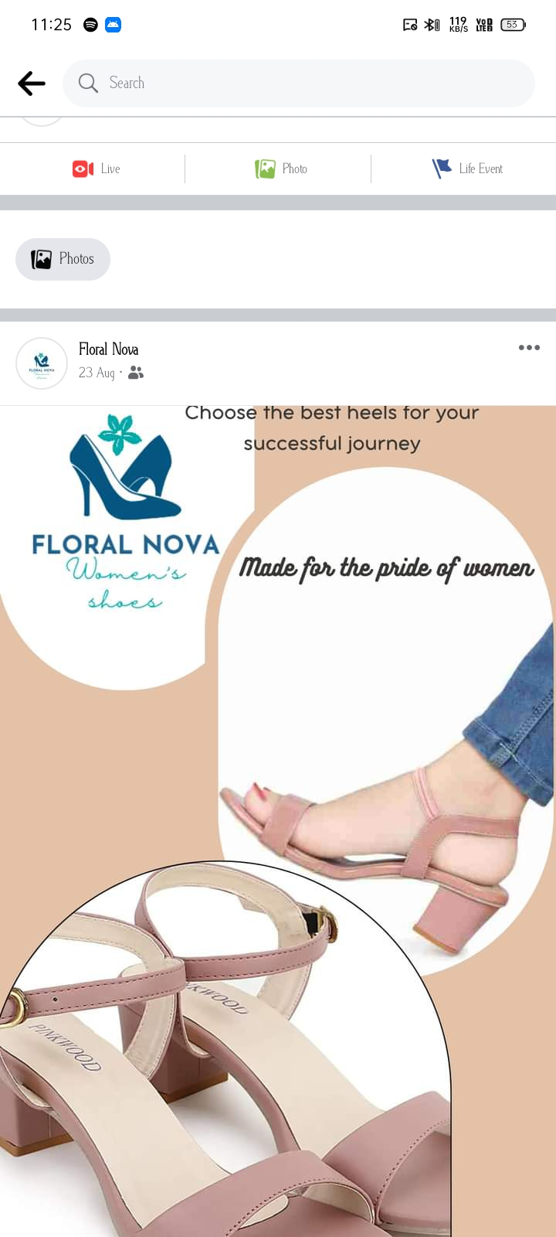

Assignment 3: Poster Creation

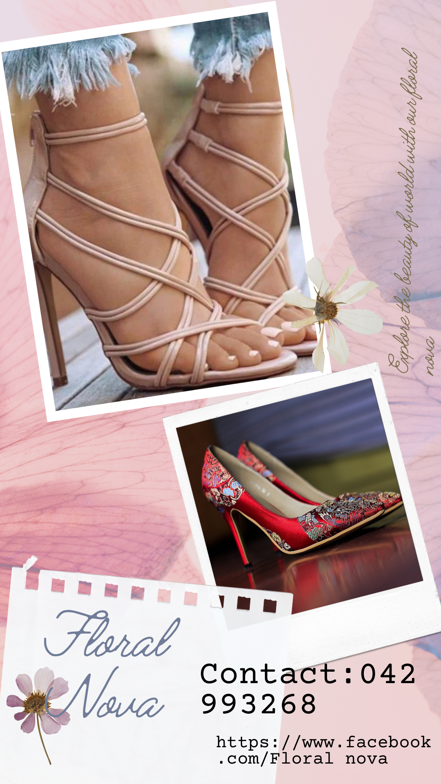

Assignment 4:News Letter Creation

